Ecommerce Sales Dashboard

Project objective: Ecommerce Sales Analysis & Dashboard (Excel)
Objective: Clean, integrate, and analysis two years of ecommerce transaction data (Oct 2023 to 2024) to find out which products, customers, stores, and regions drive revenue. Present the findings in an interactive Excel dashboard that supports sales and marketing decisions, and forecast future trends.
Dataset Description: The E-Commerce Sales Dataset contains transactional sales data covering customers, products, sales quantities, unit prices, discounts, and total sales amounts. The dataset is organized into different dimensions, such as Sales, Product, and Customer details. It can be used to analysis sales performance, product trends, customer behaviour, discounts, and revenue patterns.

Column Description:
Column Name | Description
Month | Provides order data
Customer id | Provides the customer id
Sales id | Provides the sale id for the give below
Unit price | Provides the unit price for the each product
Region | Provides the region for each state
City | Provides the city name
Gender | Provides the gender male or female
Loyalty level | Provides the loyalty level for each customer
Category | Provides the category for the product the base
Discount | Provides the discount gives to the customer

Data cleaning used formal
Converting the Raw Data into Table

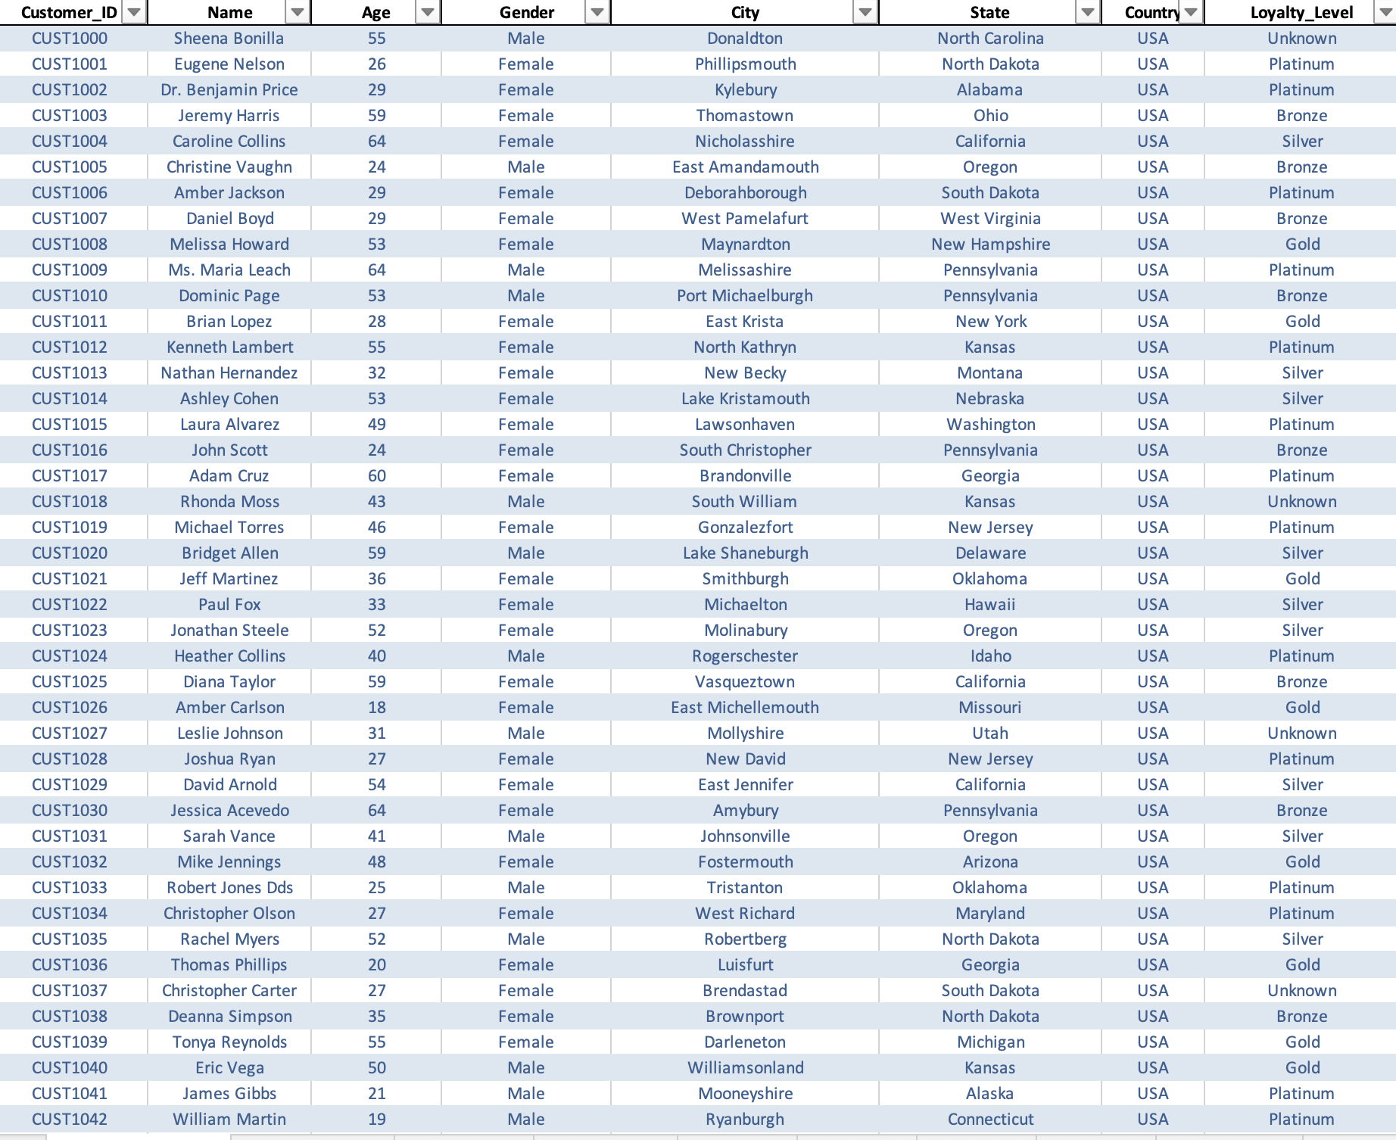
customer id typos using the find and replace
proper(trim(clean(a2)))
colunm b,e,f
proper(trim(clean(a2)))
loyalty level using blanks values replace in unknown
if(or(isblanks(h2),h2=0),"unknown",0)

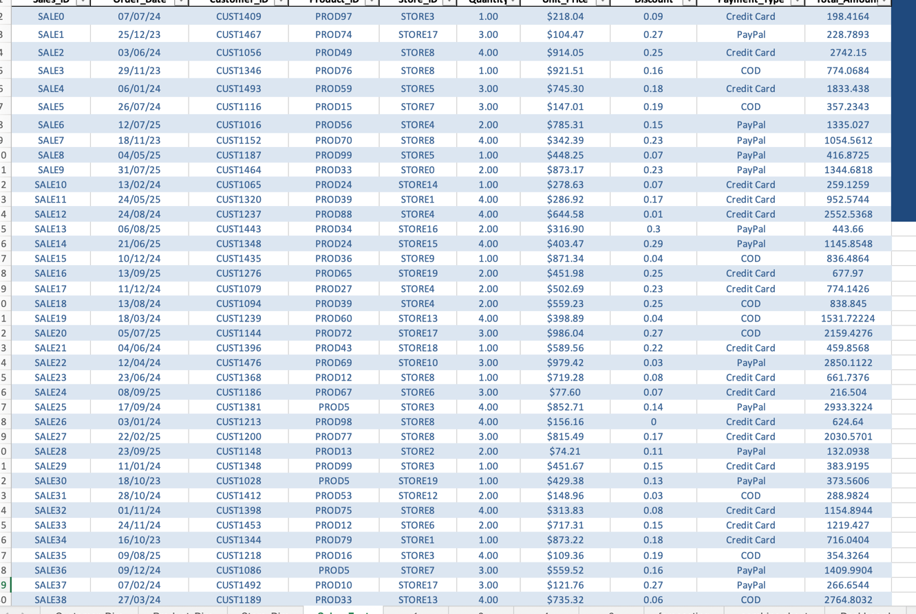

unit price handling missing value using vlooup and average
VLOOKUP([@[Product_ID]],K:L,2,FALSE)
quantity blanks colunm using the find and repalce method
using 1
discoutn blanks colunm using the find and replace method
using 0
total amount is usign quantity and unit price *
[@Quantity]*[@[Unit_Price]]*(1-[@Discount])

 | Total_Amount |  | Unit_Price
 | Mean | 1085.156254 | Mean | 513.8903767
 | Standard Error | 18.30980344 | Standard Error | 6.308112311
 | Median | 866.6988 | Median | 522.43
 | Mode | #N/A | Mode | 871.34
 | Standard Deviation | 818.8393028 | Standard Deviation | 282.1073587
 | Sample Variance | 670497.8038 | Sample Variance | 79584.56185
 | Kurtosis | 0.067465901 | Kurtosis | -1.190105562
 | Skewness | 0.887468332 | Skewness | -0.035794762
 | Range | 3889.7838 | Range | 979.8
 | Minimum | 18.459 | Minimum | 20.09
 | Maximum | 3908.2428 | Maximum | 999.89
 | Sum | 2170312.509 | Sum | 1027780.753
 | Count | 2000 | Count | 2000
 | Largest(1) | 3908.2428 | Largest(1) | 999.89
 | Smallest(1) | 18.459 | Smallest(1) | 20.09
 | Confidence Level(95.0%) | 35.90829701 | Confidence Level(95.0%) | 12.37116342
Used Descriptive Statistics using Toolpak

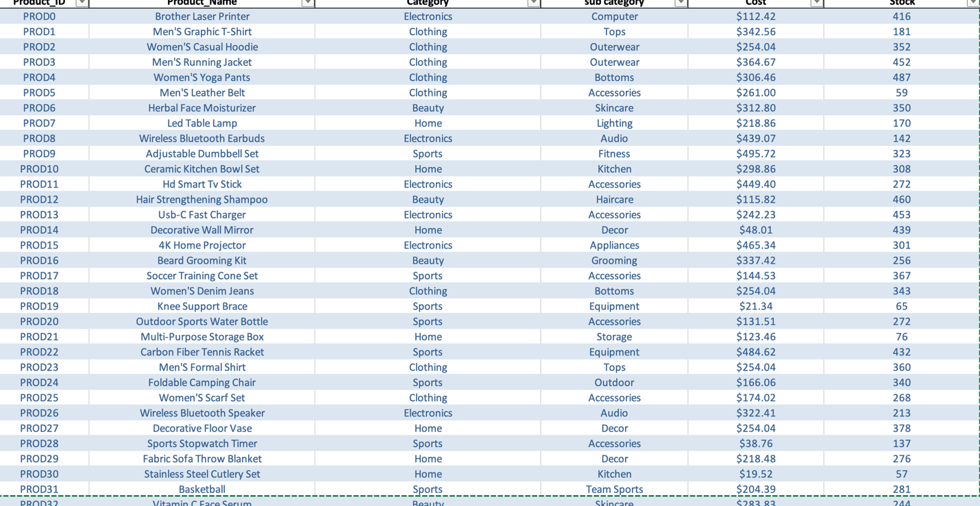

Using the formal :
=if(or(isblank(e2),e=0),average(e:e),e2)

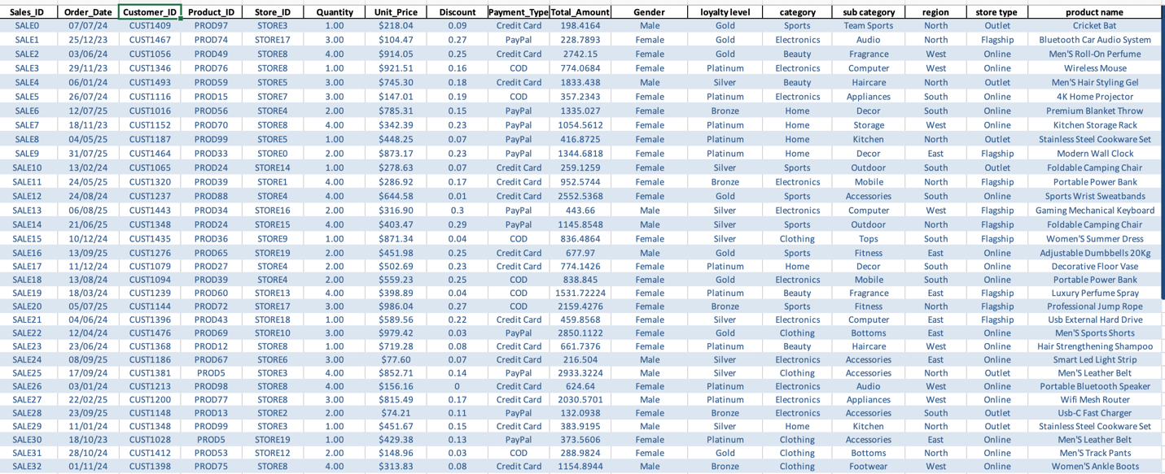

using the vlookup formal combine sheet in gender colunm for analysis
for pivot tabless
VLOOKUP([@[Customer_ID]],Customer_Dim!A:D,4,FALSE)
using the vlookup formal combine sheet in loyalty level colunm for analysis
for pivot tabless
VLOOKUP([@[Customer_ID]],Customer_Dim!A:H,8,FALSE)
using the vlookup formal combine sheet in poduct id category colunm for analysis
for pivot tabless and also sub category
VLOOKUP([@[Product_ID]],Product_Dim!A:D,3,FALSE)
VLOOKUP([@[Product_ID]],Product_Dim!A:D,4,FALSE)
using the vlookup formal combine sheet in region colunm for analysis
which region highest sale for pivot tables
VLOOKUP([@[Store_ID]],Store_Dim!A:D,3,FALSE)
using the vlookup formal combine sheet in region colunm for analysis
for which store type sale
VLOOKUP([@[Store_ID]],Store_Dim!A:E,5,FALSE)

Visualization and Insights Arrived with screenshot of visualization
Report/Dashboard screenshot:
1. Descriptive Analysis — What happened?

What is the average sales value per order?
Which product category has the highest sales?
Which region/store generated the highest sale?/

2. Diagnostic Analysis — Why did it happen?
Why did one product category generate higher sales than another?
Which products contributed most to the difference in sales?
3. Predictive Analysis — What is likely to happen?
Based on historical sales, can we forecast future revenue?
Which stores/regions are likely to continue performing well?
4. Prescriptive Analysis — What should we do?
Which products should the company promote to increase sales?
What discount strategy could improve sales?

Dashboard Image:

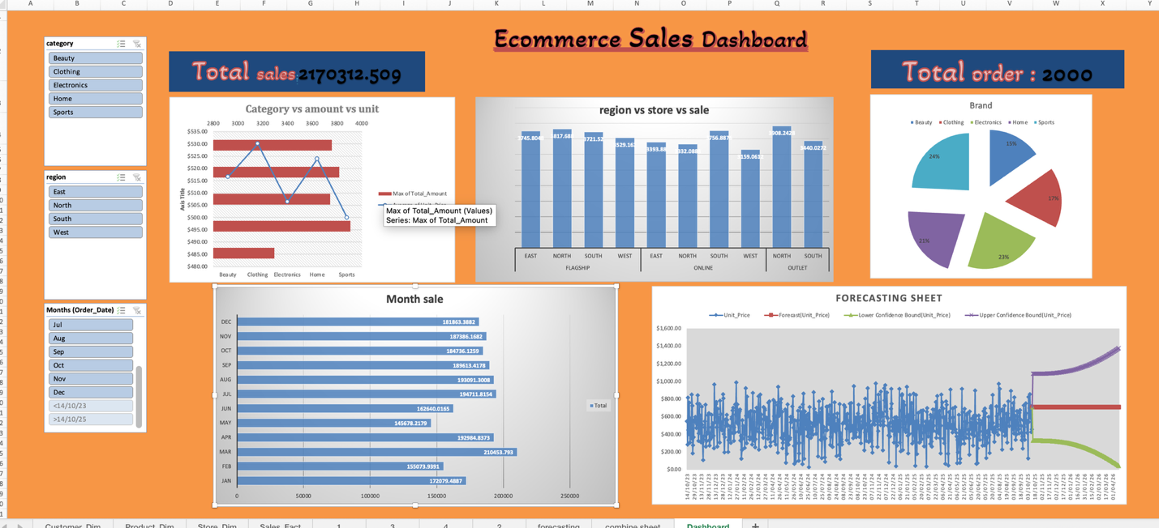
Final 4 type of insight for storyline :
We have 2000 sale order placed order by customer and total sale amount $ 2170312.509 in sale amount and bought 4,960 total items , the average order was about $1,087. Out of all category sport and electronics and home products. The payment method is customer have credit card and paypal and also (COD) cash o delivery . Electronics and Sports look like they will keep growing and remain customer favorites. Put more advertising and stock into our top-selling categories like Sports and Home . West region only has 12% of sales, so we should run special promos there to catch up with the North and East.
Conclusion:
This project taught me that data isn't just a scary spreadsheet, it is actually a story about people shopping, buying, and helping a business grow. I am so proud of building my first dashboard and finding these insights.

Thank you

